PROJECT

CONTENTS

- Certification of submission

- Introduction

- Proposed solution

- Modules

- Features

- Front end/Back end

- Hardware/Software requirements

- Data Base

- Pages

INTRODUCTION

Today everyone need legal services for some or the other reason. It is very difficult to find lawyers with respective specialization. Getting appointment is also very difficult. There is a need to have a website for doing all this.

PROPOSED SOLUTION

We designed and develop a website for lawyers and their service. Customers can register and search for lawyers basing their requirement. Info related to lawyers will be there in website which customers can browse through and view their profile before contacting them.

Customers can book a schedule for meeting with lawyer. We also had a discussion in regard to few clarifications and inputs specifically to understand the project flow.

MODULES
- Admin
- Lawyer
- General user.

FEATURES OF LAWYER MANAGEMENT SYSTEM PROJECT
- Building a web-based solution: We have built a web-based online lawyer management system where lawyers can be registered and found easily with filtering option.
- User log in system: I have created three types of user login system.
1. Admin
2. Lawyer
3. General user.
Each type of users has to put their email ID and password to log in into the system.
- Register users with validation: We have created two types of user registration one is for lawyers and the other is for general users. We have created strong validation from the backend of the system which can’t be bypassed easily.
- Admin report generate: We have built a function for the admin in their dashboard. They will be able to check various information about their system. For example, how many lawyers are registered into their website, how many experienced lawyers are registered etc. all these data will be shown to them through pie charts.
- User friendly interface: We have tried to keep the user interface as much friendlily as we can.
- Filtering search option: One of the major features of my system is general users will be able find lawyers through searching option.
- Booking system general user end: In this system general user can check out lawyer’s profile and send them booking request. They will be able to see later whether their booking request is accepted or not.
- Booking system lawyers end: Lawyers will be able to check their latest booking requests once they are logged in. they will be also able to accept the booking request if they are agree to meet the client.
- Admin will be able to login to the system with their registered id and password which is stored in database. System admin will be able to see lawyers and general user’s profile and manipulate their account
- Once lawyers are registered admin approval will be needed to login into the system. The admin will get the chance to verify whether the lawyer is genuine or not.
- Admin will also be able to block users from the system if any inconvenience happens.
- The system enables web-based booking system.
- Both type of user will be able to update their profile once they are logged in into the system.
- Any guest user will be able to see the lawyers and check their profile. But for booking the lawyer they must have to register.

FRONT END: HTML, CSS, JAVASCRIPT
- HTML: HTML is used to create and save web document. E.g. Notepad/Notepad++
- CSS : (Cascading Style Sheets) Create attractive Layout
- Bootstrap : responsive design mobile friendly site
- JavaScript: it is a programming language, commonly use with web browsers.
BACK END: PHP, MYSQL:
- PHP: Hypertext Preprocessor (PHP) is a technology that allows software developers to create dynamically generated web pages, in HTML, XML, or other document types, as per client request. PHP is open source software.
- MySQL: MySQL is a database, widely used for accessing querying, updating, and managing data in databases.

HARDWARE/ SOFTWARE REQUIREMENTS

Hardware
- A minimum computer system that will help you access all the tools in the courses is a Pentium 166 or better
- 128 Megabytes of RAM or better

Operating System
- LINUX / Windows 2000 Server (or higher if possible)

Software
- PHP
- MySQL
- PERL
- Apache

DATA BASE

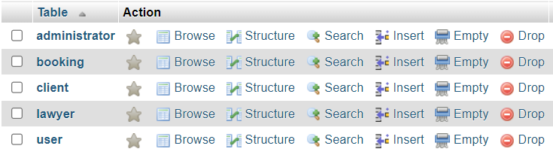

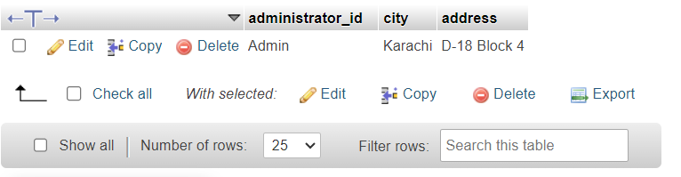

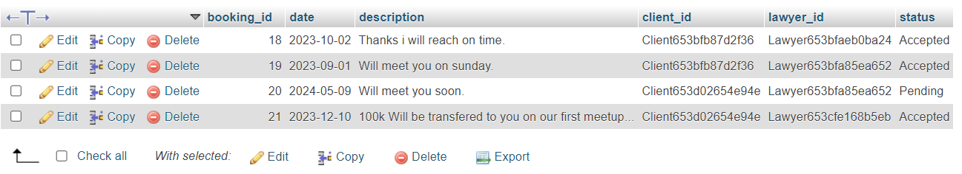

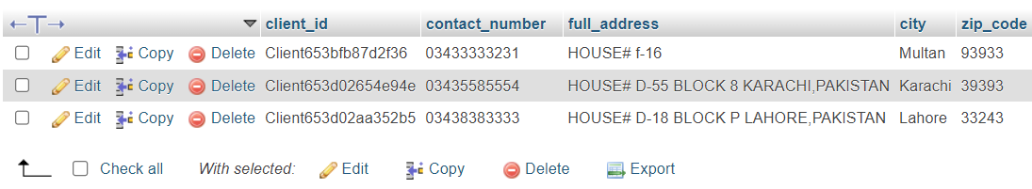

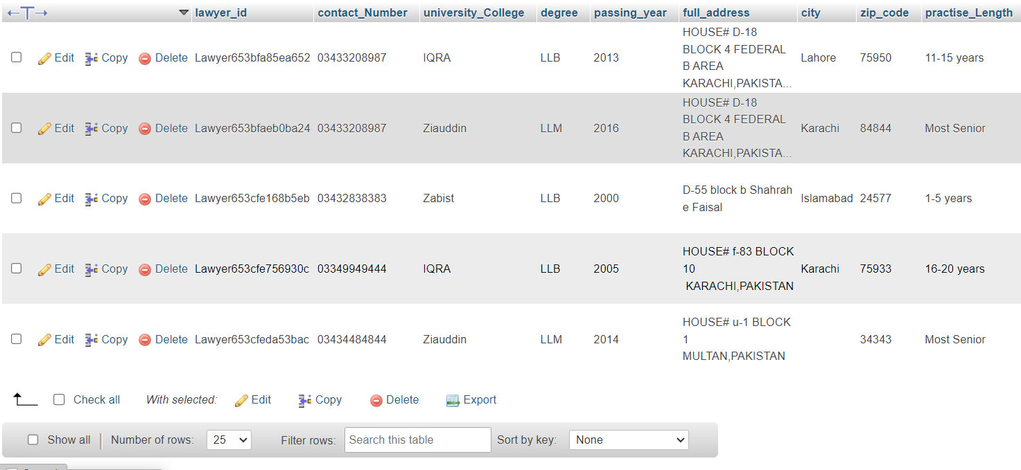

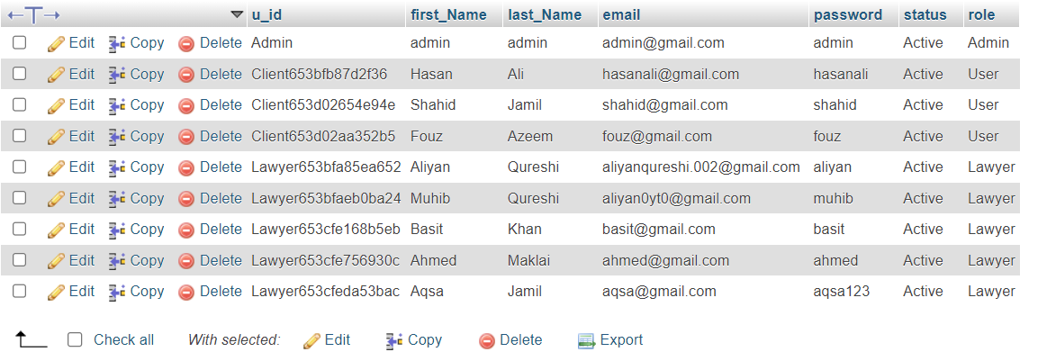

PAGES NAMES

- HOME

- LAWYERS

- LOGIN

- REGISTER
USER
LAWYER

- ADMIN PANEL
DASHBOARD
SEE LAWYERS
SEE USERS

- LAWYER PANEL
DASHBOARD
EDIT PROFILE
BOOKING REQUEST
UPDATE PASSWORD

- USER PANEL
DASHBOARD
LAWYERS
EDIT PROFILE
MY BOOKING REQUEST
UPDATE PASSWORD

HOME:

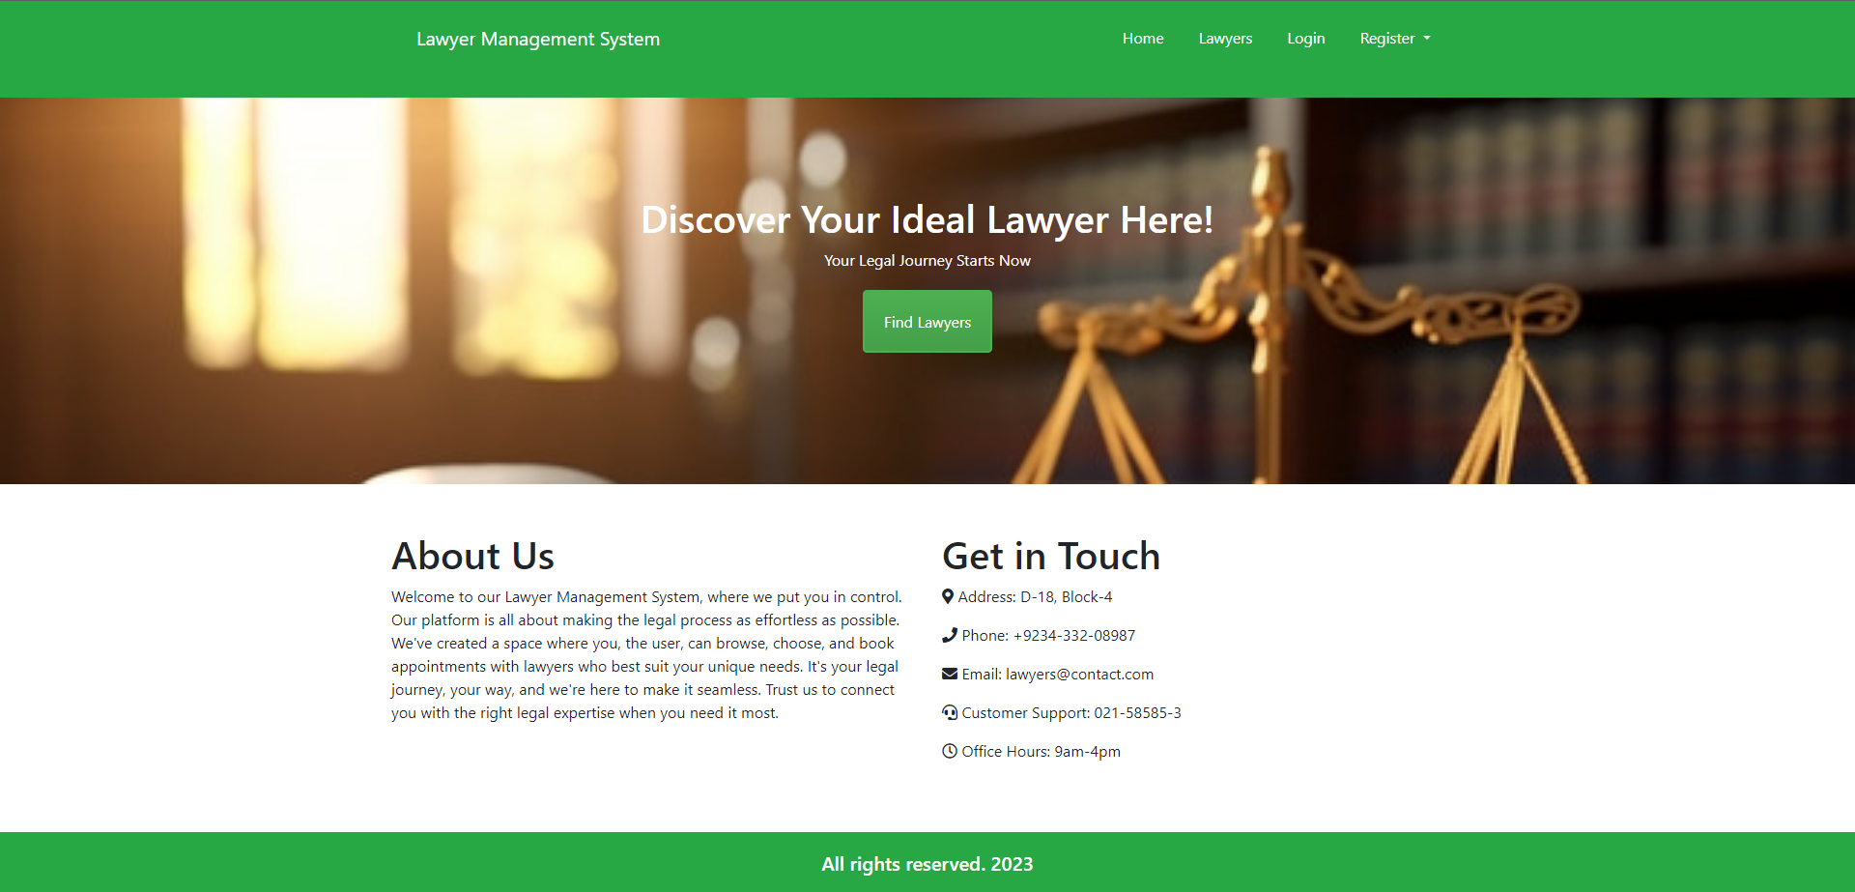

LAWYERS:

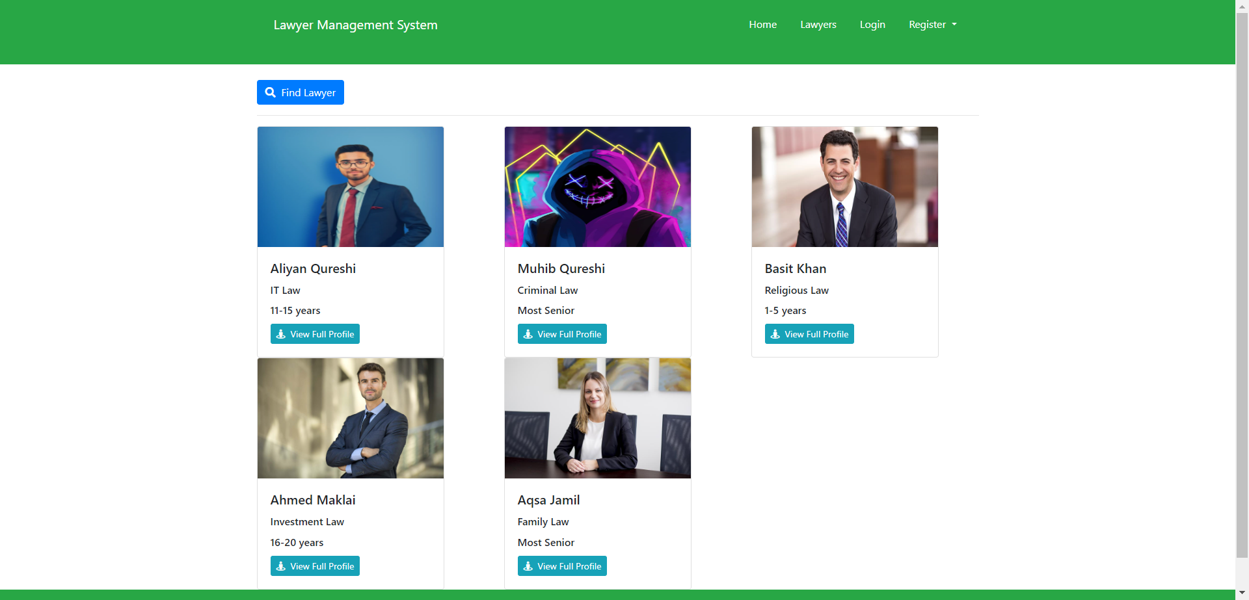

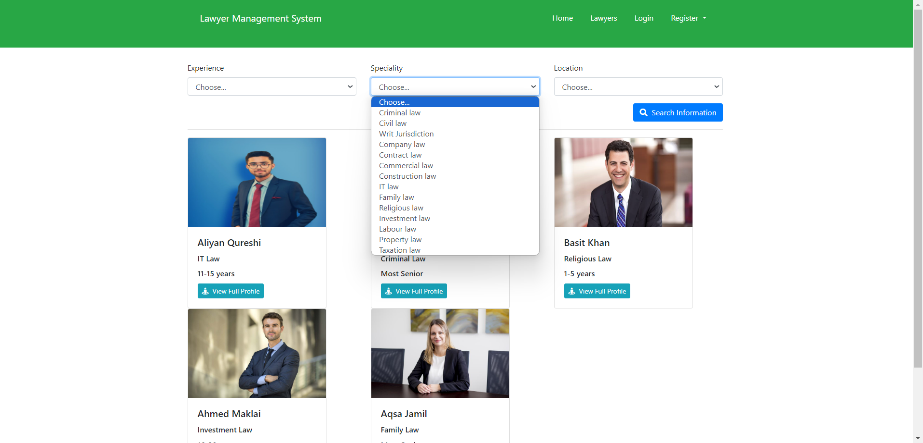

LOGIN:

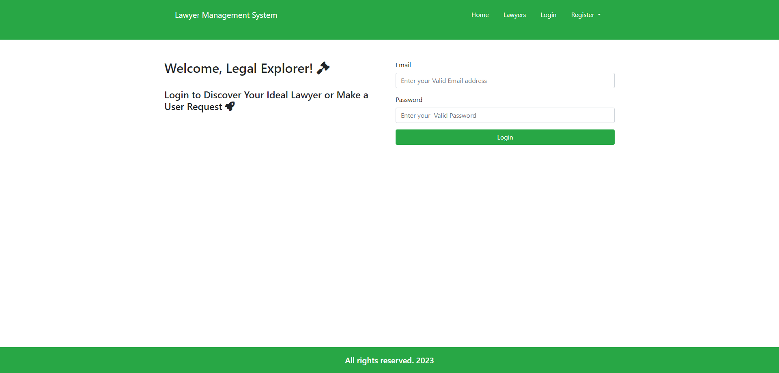

REGISTER: (LAWYER AND CLIENT)

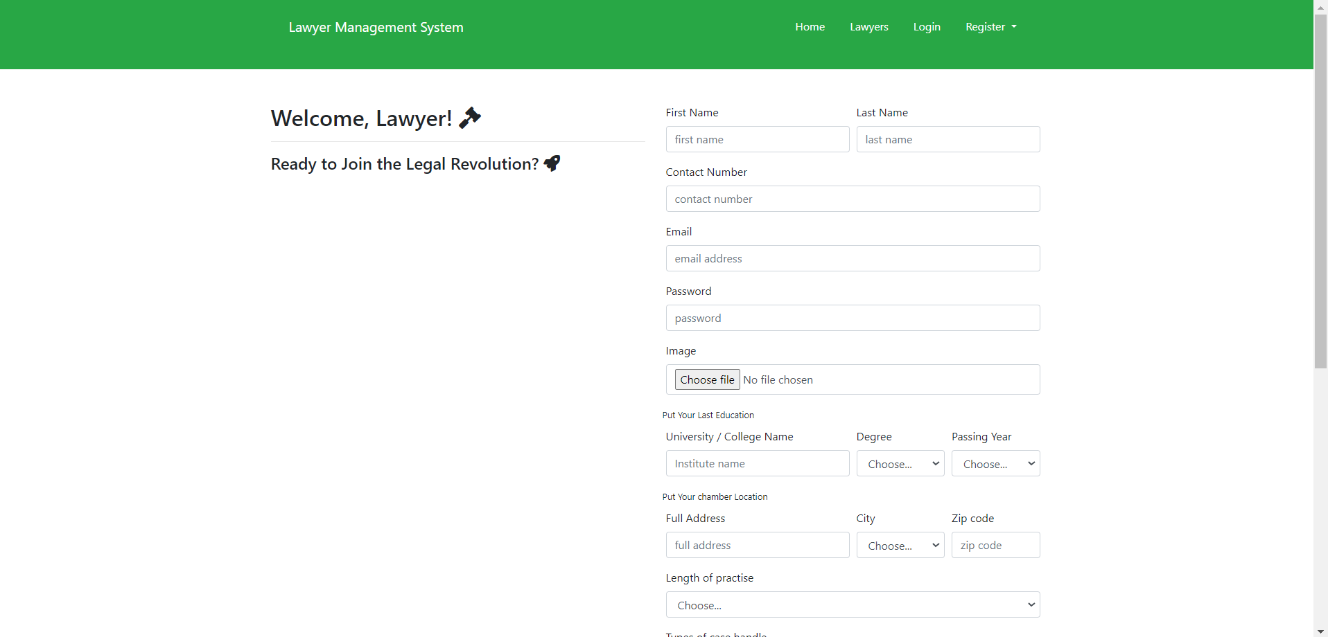

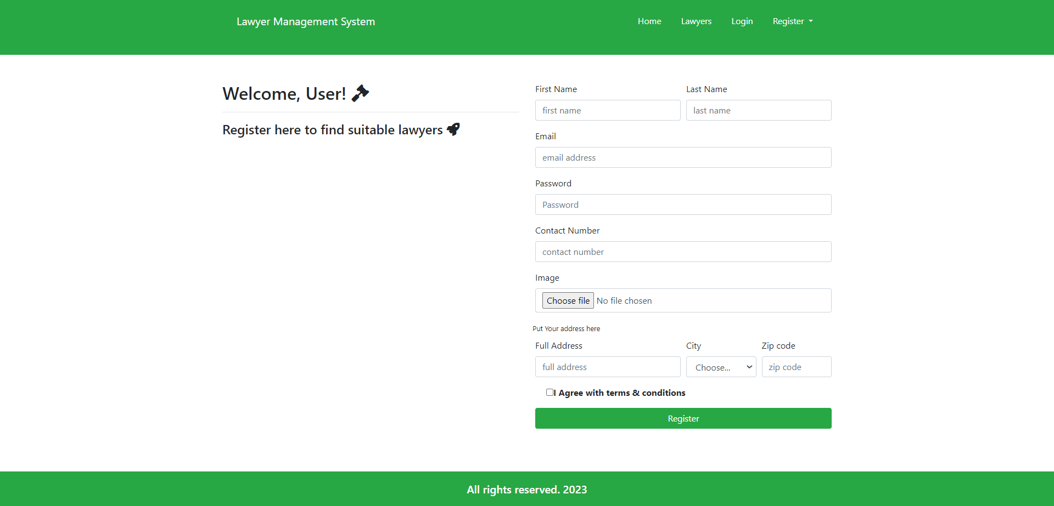

ADMIN PANEL:

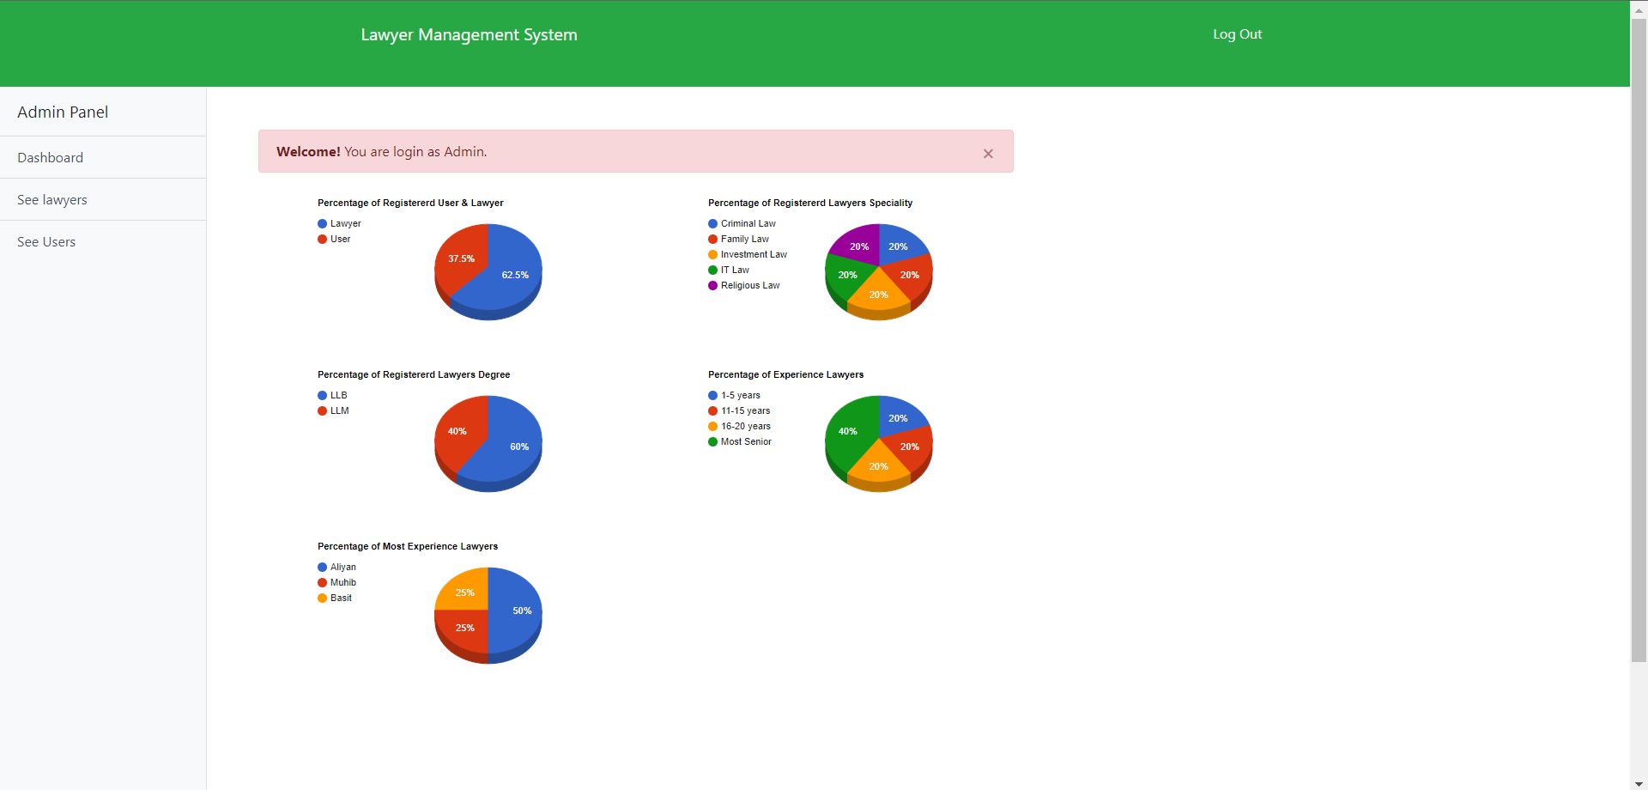

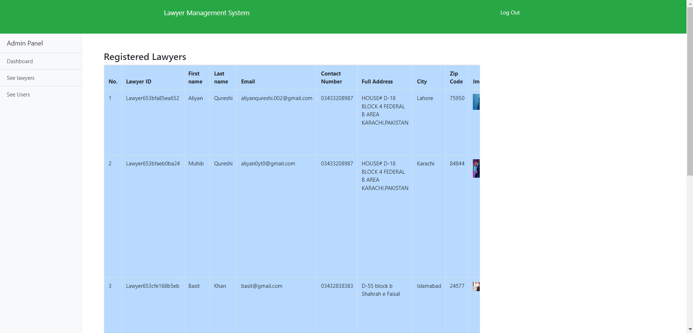

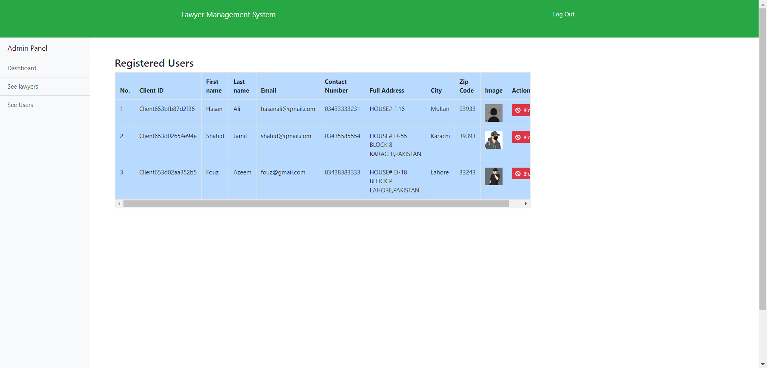

LAWYER PANEL:

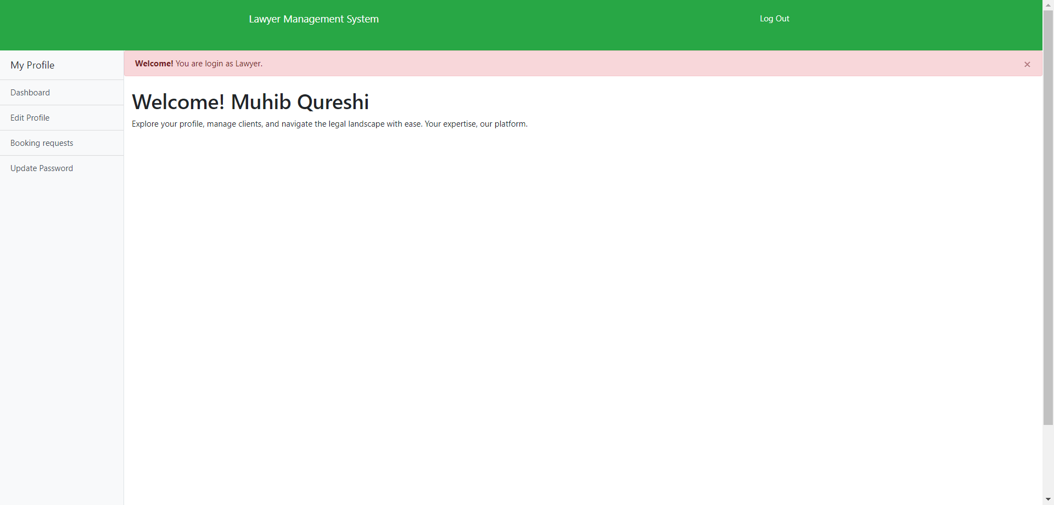

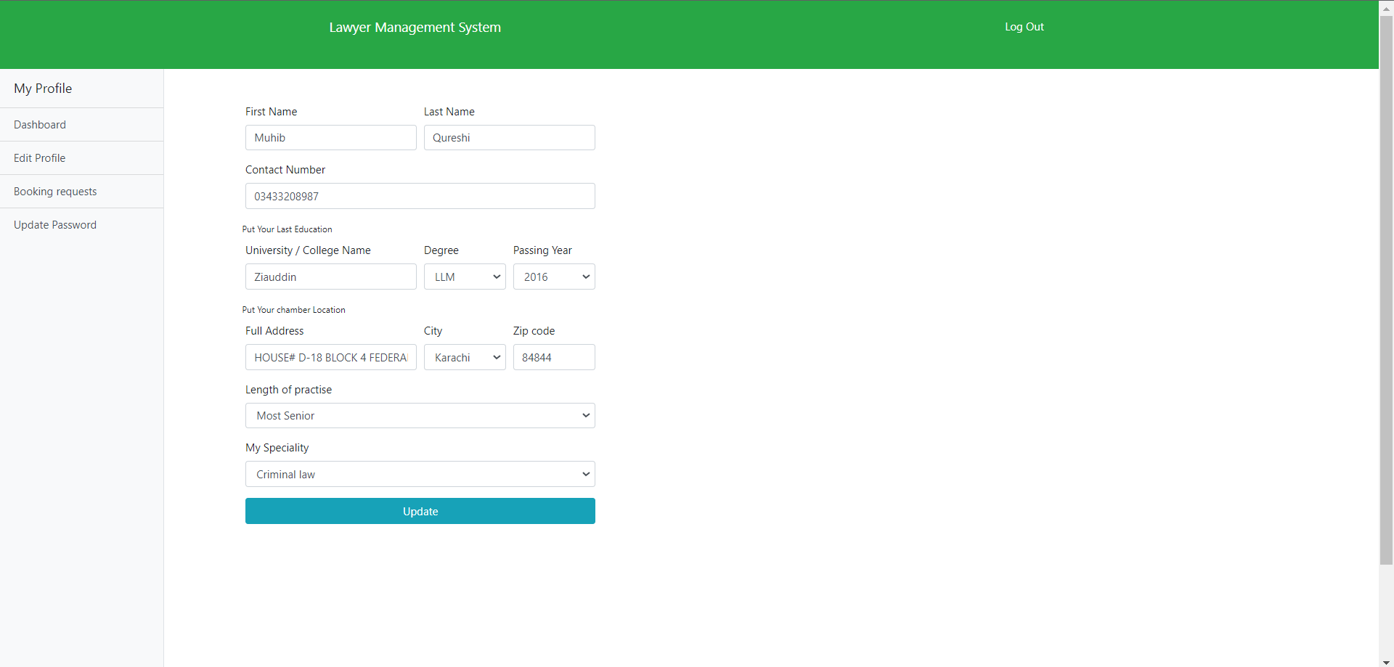

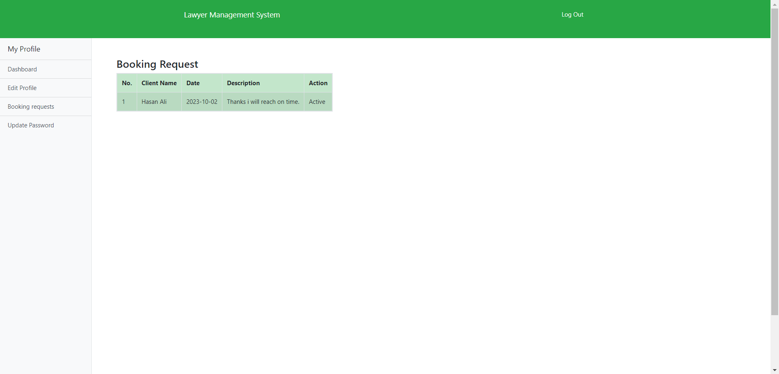

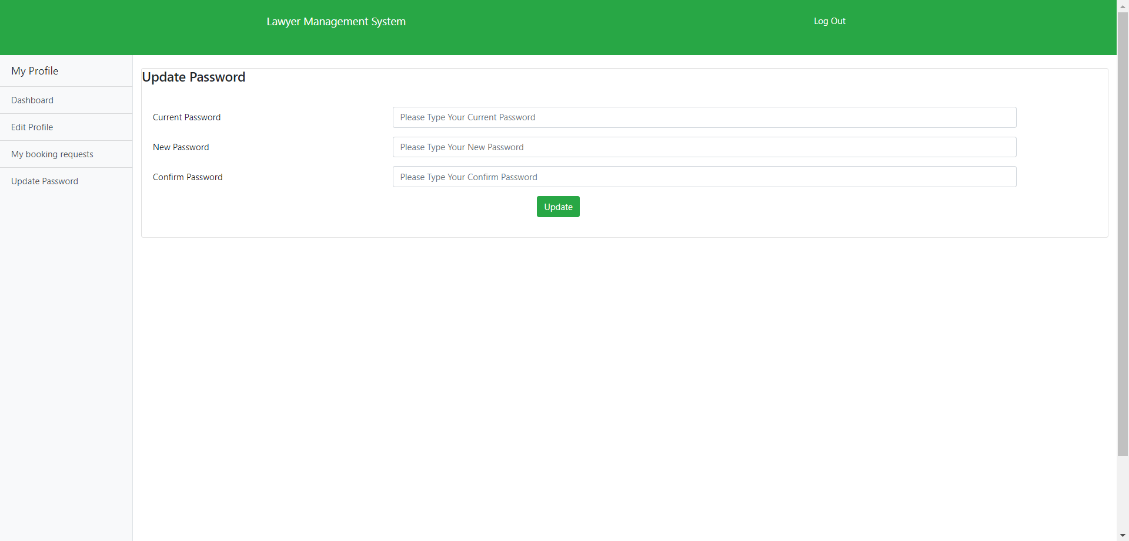

USER PANEL:

